# Transistor Amplifiers

# 

# 1 Introduction

This tutorial shows different types of transistor amplifiers.

Nowadays there are a number of low cost high quality power or instrumentation amplifier ICs that can be used for:

* audio (speaker amplifiers),
* sensors (automations, alarms),
* medical (Electrocardiogram (ECG), EEG (electroencephalogram)),
* instrumentation (multimeter, oscilloscope, spectrum, analyser, light/sound metres).

applications.

Thus transistor amplifiers are mostly useful for DIY electronics, thus eliminating the need for:

* expensive soldering irons or good soldering skills,
* waiting for a replacement of a damage IC to come in the mail,
* wire wrap sockets or wire wrap tools,
* PCB layout and production.

However, transistors are still used in certain electronic circuits for high power applications.

There are five most well known ways of biasing a BJT transistor:

1. Fixed bias amplifier.
2. Stabilised bias amplifier.
3. Feedback bias amplifier.
4. Feedback bias amplifier with emitter resistor (similar to stabilised bias).
5. Voltage follower.

# 2 Fixed Bias Amplifier

A bipolar junction transistor (BJT) amplifier could be made with either NPN or PNP transistors.

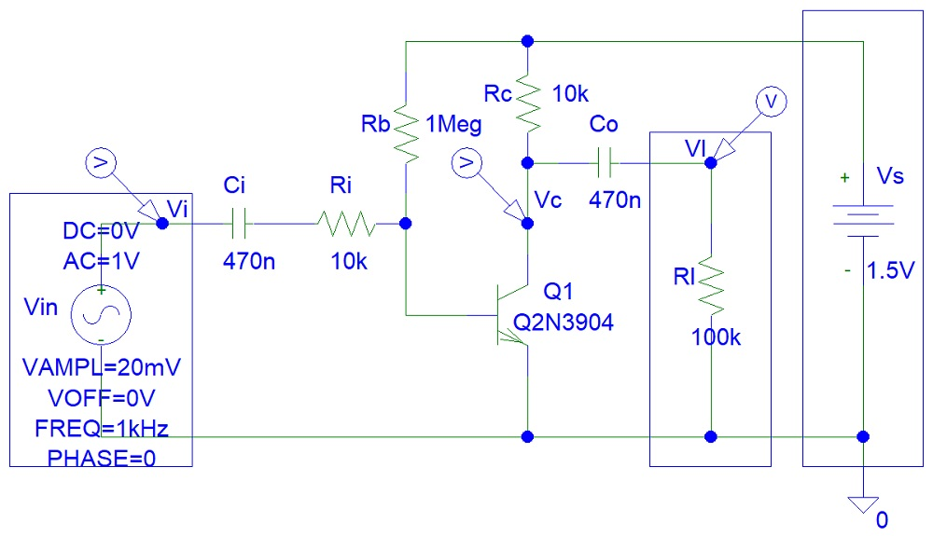

Figure 1: NPN Transistor Fixed Bias Amplifier.

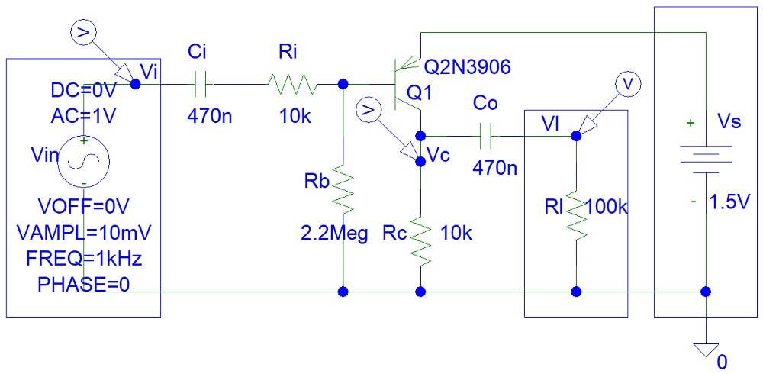

Figure 2: PNP Transistor Fixed Bias Amplifier.

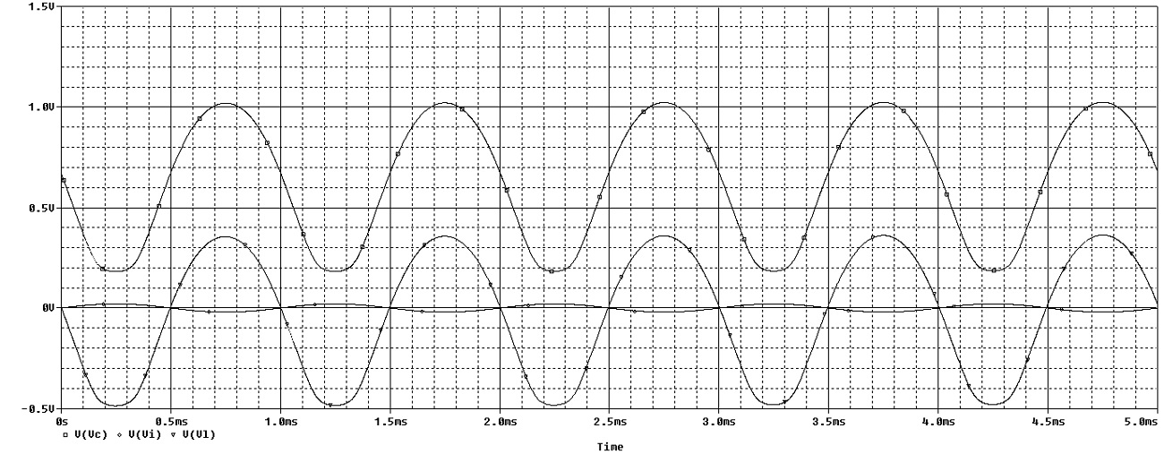

Figure 3: NPN Transistor Amplifier Time Domain Simulations.

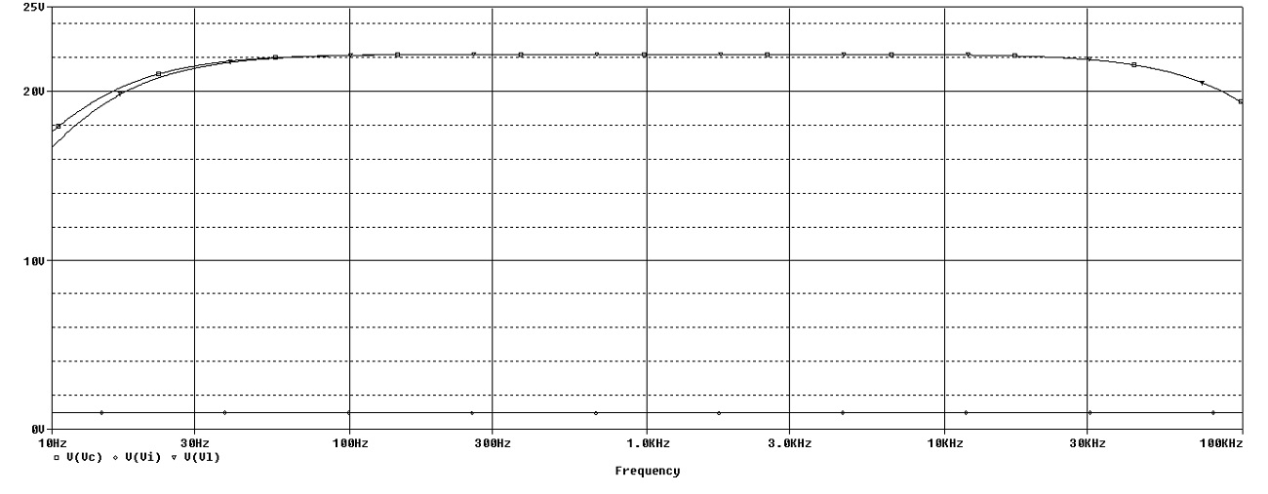

Figure 4: NPN Transistor Amplifier Frequency Domain Simulations.

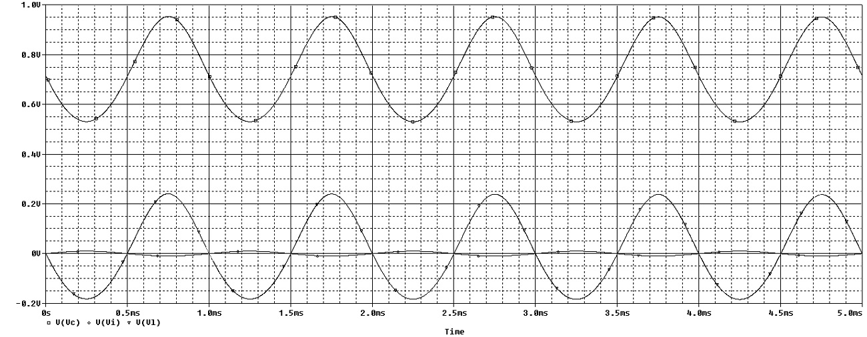

Figure 5: PNP Transistor Amplifier Time Domain Simulations.

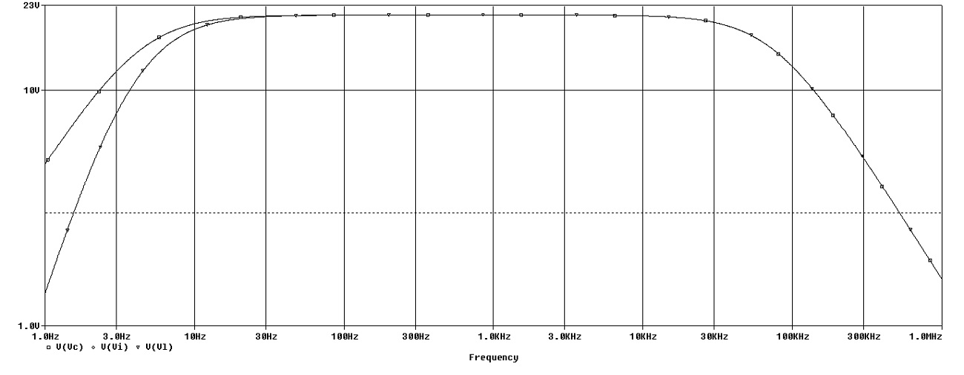

Figure 6: PNP Transistor Amplifier Frequency Domain Simulations.

# 

# 3 Conclusion

This tutorial does not include the transistor amplifier heat sink selection that is very important for power amplifiers.

Charles Amplayo

Electronic Circuit Project